[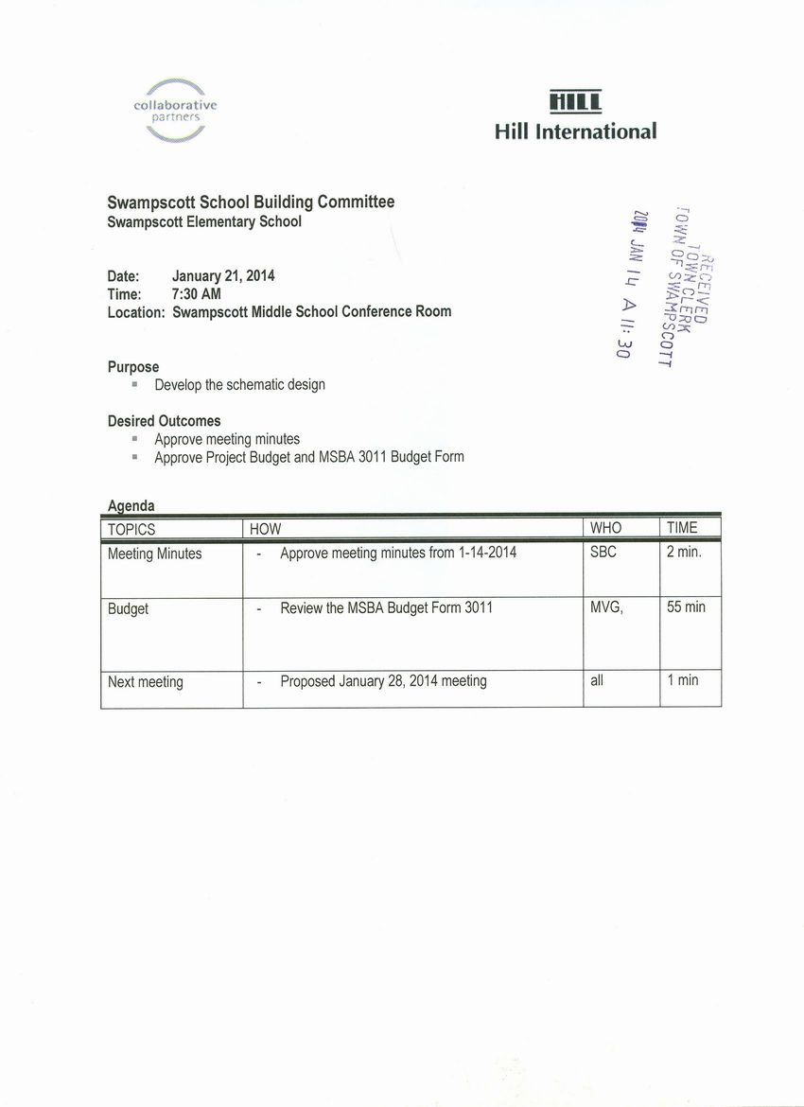](http://www.town.swampscott.ma.us/Public_Documents/SwampscottMA_Calendar/S0452D854-0452D877.0/School%20Building%20Committee%20Jan%2021st%20notice%20001.jpg)